Manipal Institute of Technology
Manipal Academy of Higher Education
MCA 5141: Machine Learning Lab
Mini Project Report, Phase 3
Instagram Influencer Analysis Using Machine Learning
Model Evaluation, Selection and Deployment
Submitted by
Vaibhavi Nayak (Reg. No. 251090700139)
Prakruthi K S (Reg. No. 2510907000197)
Academic Year 2026, Batch A2

1. Problem Statement and Objective

1.1 Problem statement
Brands use an influencer’s overall rating, called influence_score in our dataset (range 22 to 93), when deciding sponsorship budgets. The rating is given to us as a number, but the account metrics behind it (followers, posts, likes, engagement rate and country) are public. In this project we study how well influence_score can be predicted from those metrics. This is a regression problem.
The data has four difficulties. Follower counts are highly skewed, from 32.8 million to 475.8 million. The numbers are stored as text such as 3.3k, 475.8m, 29.0b and 1.39%. The country column is missing for 62 of the 200 accounts (31%). Finally, the signal is weak: engagement rate does not increase with audience size, so a simple linear trend does not explain the score well.

1.2 Objectives
- Build a preprocessing pipeline that is fitted on training data only, so that no information leaks from the validation or test data.
- Train and compare nine regression models, five of which are ensembles (Random Forest, Extra Trees, Gradient Boosting, AdaBoost and a Voting Regressor).
- Evaluate every model with 5-fold cross-validation on the training set, on a held-out validation set, and on an external test set of five Indian influencers.
- Compare the models with a baseline that always predicts the training mean, to check that they learn something useful.
- Select the best model using a stated rule and report its weaknesses.
- Save the selected pipeline with joblib and deploy it as a Streamlit application.
- Document the use of AI tools in this work (Section 7).

2. Meta Data
Table 1 summarises the dataset and Table 2 describes each column.
Table 1: Dataset summary
Property | Value
Primary file | top_insta_influencers_data.csv
Size | 200 rows and 10 columns; all handles are unique and there are no duplicate rows
Target | influence_score (integer): minimum 22, median 84, maximum 93, mean 81.8, standard deviation 8.9
Missing values | country only: 62 of 200 (31%)
Countries | 25 distinct values. United States 66, Brazil 13, India 12, Indonesia 7, France 6
Train/validation split | 80/20 with random_state = 42 (160 training rows, 40 validation rows)
External test file | 5_additional_indian_influencers_test_data.csv (5 accounts, not part of the training data)
Table 2: Column description
Column | Raw type | Cleaned type | Role | Description
rank | int64 | dropped | Identifier | Rank by followers; dropped because it is derived from followers
channel_info | object | dropped | Identifier | Account handle, e.g. cristiano
influence_score | int64 | float | Target | Influence rating to be predicted
posts | object | float | Feature | Total posts, e.g. 3.3k = 3,300
followers | object | float | Feature | Follower count, e.g. 475.8m = 475,800,000
avg_likes | object | float | Feature | Average likes per post, e.g. 8.7m
60_day_eng_rate | object | float | Feature | Engagement rate over 60 days, e.g. 1.39% = 1.39
new_post_avg_like | object | float | Feature | Average likes on recent posts, e.g. 6.5m
total_likes | object | float | Feature | Total likes, e.g. 29.0b
country | object | one-hot | Feature | Country; missing values become “Unknown”

Table 3: External test set (five Indian influencers)
Handle | Followers | Country | Actual score
rashmika_mandanna | 51.1 M | India | 82
iamsrk | 48.4 M | India | 84
hardikpandya93 | 44.7 M | India | 83
rohitsharma45 | 46.1 M | India | 80
rishabpant | 16.1 M | India | 76

3. Exploratory Analysis and Preprocessing Pipeline

3.1 Exploratory analysis
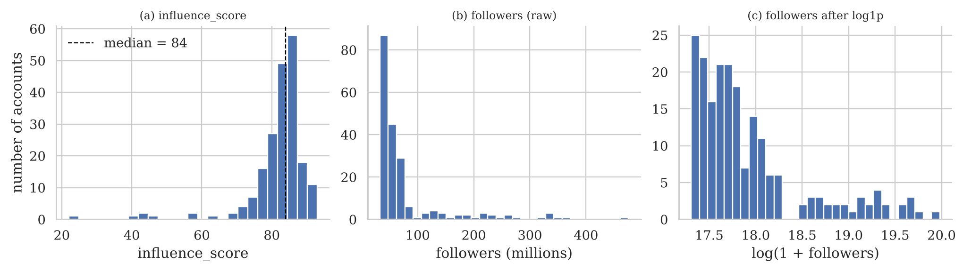
Figure 1: Distribution of the target and of followers before and after the log transform
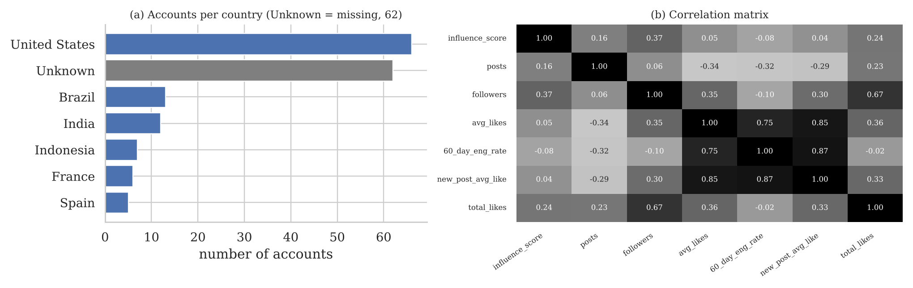
Figure 2: Accounts per country and correlation matrix of the numeric columns
We made the following observations.
- The target is skewed to the left (skewness −3.47). Most accounts score between 80 and 86, but a few score as low as 22 to 47. These few points raise RMSE and lower R² much more than they affect MAE.
- Followers are skewed to the right (skewness 2.80). After the log1p transform the skewness drops to 1.55.
- Followers has the highest correlation with the score (0.37), followed by total_likes (0.24) and posts (0.16). Engagement rate has a small negative correlation (−0.08).
- avg_likes, new_post_avg_like and 60_day_eng_rate are strongly correlated with each other (0.75 to 0.87). We kept all three because tree models and Ridge regression can handle correlated inputs.
- Country is missing for 31% of accounts. Instead of deleting these rows we treat missing as its own category, Unknown.

3.2 Preprocessing pipeline
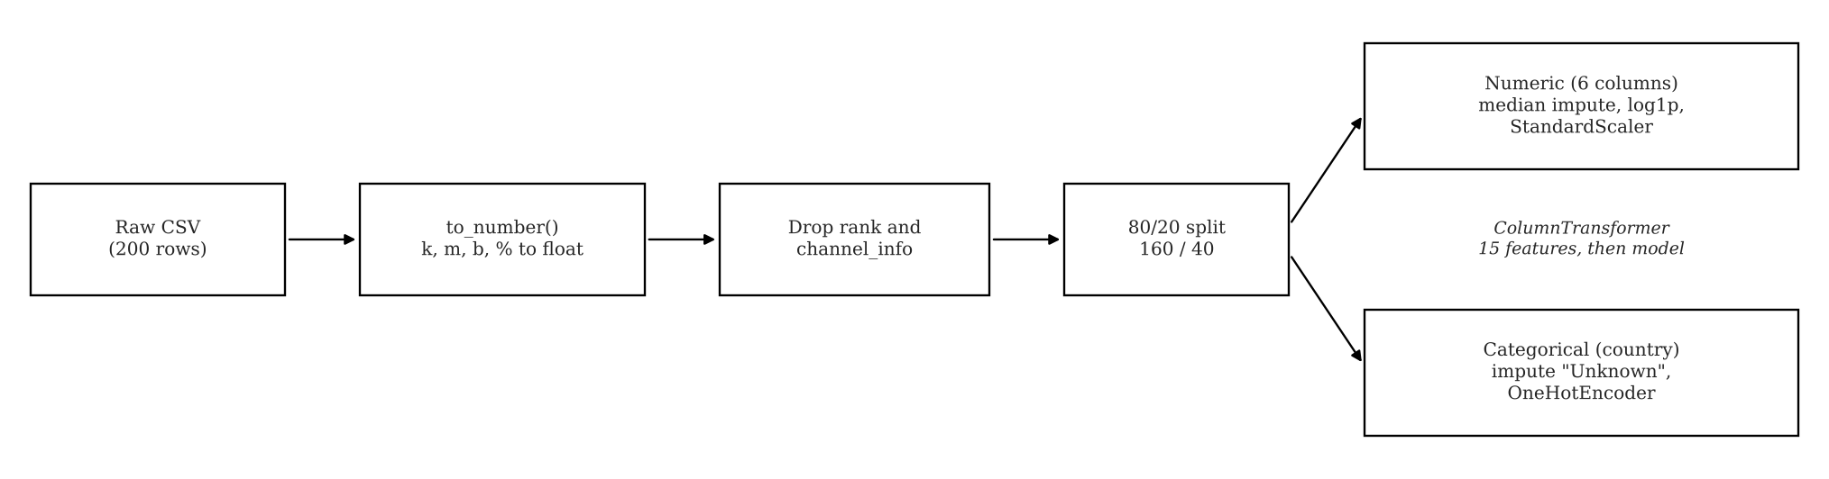
Figure 3: Preprocessing pipeline
The steps, in order, are given in Table 4. Every step that learns from data (imputer, scaler, encoder) is inside a scikit-learn Pipeline and ColumnTransformer and is fitted only on the 160 training rows. The output has 15 features: 6 numeric columns and 9 one-hot columns for country.
Table 4: Preprocessing steps
No. | Step | Reason
1 | Convert text numbers with to_number() | Turns k, m, b and % values into floats
2 | Drop rank and channel_info | rank is computed from followers; the handle is only an identifier
3 | 80/20 train/validation split | Keeps 40 accounts unseen during training
4 | Median imputation for numeric columns | The median is not affected by extreme follower counts
5 | log1p transform | Reduces the right skew of the counts
6 | StandardScaler | Needed for Ridge, KNN and SVR
7 | Impute “Unknown” and one-hot encode country (min_frequency = 3) | Keeps rows with missing country; rare countries are grouped together

4. Model Evaluation Metrics
The values below are taken from model_evaluation_metrics.csv, which is produced by the notebook. CV is 5-fold cross-validation on the 160 training accounts (mean ± standard deviation over the folds). Validation is the set of 40 held-out accounts. The external set has five accounts. Rows are sorted by validation MAE, and the selected model is in bold.
Table 5: Cross-validation and validation results
Model | Type | CV MAE | CV RMSE | CV R² | Val MAE | Val RMSE | Val R²
Gradient Boosting | Ensemble (boosting) | 4.41 ± 0.86 | 6.82 ± 2.17 | −0.021 | 5.31 | 12.68 | +0.049
Voting Regressor | Ensemble (voting) | 3.89 ± 0.96 | 6.24 ± 2.45 | +0.204 | 5.33 | 13.05 | −0.008
KNN Regressor | Instance-based | 4.19 ± 0.97 | 6.65 ± 2.38 | +0.069 | 5.43 | 13.15 | −0.023
Extra Trees | Ensemble (bagging) | 4.04 ± 0.80 | 6.52 ± 2.13 | +0.082 | 5.45 | 13.03 | −0.004
Support Vector Regressor | Kernel | 3.72 ± 1.28 | 6.14 ± 2.89 | +0.251 | 5.46 | 13.37 | −0.058
Ridge Regression | Linear | 4.22 ± 0.83 | 6.52 ± 2.19 | +0.086 | 5.51 | 12.88 | +0.019
Random Forest | Ensemble (bagging) | 4.32 ± 0.90 | 6.64 ± 2.24 | +0.057 | 5.57 | 13.15 | −0.023
AdaBoost | Ensemble (boosting) | 4.02 ± 1.02 | 6.35 ± 2.48 | +0.176 | 5.64 | 13.15 | −0.023
Decision Tree | Tree | 4.47 ± 1.04 | 7.08 ± 2.16 | −0.114 | 5.95 | 13.24 | −0.037
Baseline (training mean) | Reference | - | - | - | 6.27 | 13.22 | −0.033
Table 6: Training fit and external test results
Model | Train R² | Val R² | Ext MAE | Ext RMSE | Ext R²
Gradient Boosting | 0.555 | +0.049 | 1.95 | 2.36 | +0.31
Voting Regressor | 0.520 | −0.008 | 1.83 | 2.48 | +0.23
KNN Regressor | 1.000 | −0.023 | 3.54 | 4.58 | −1.63
Extra Trees | 0.567 | −0.004 | 2.02 | 2.22 | +0.38
Support Vector Regressor | 0.325 | −0.058 | 2.46 | 2.82 | +0.01
Ridge Regression | 0.337 | +0.019 | 2.96 | 3.66 | −0.67
Random Forest | 0.668 | −0.023 | 2.42 | 3.23 | −0.31
AdaBoost | 0.587 | −0.023 | 1.56 | 1.89 | +0.55
Decision Tree | 0.476 | −0.037 | 3.07 | 4.25 | −1.26
Baseline (training mean) | - | −0.033 | 2.26 | 3.11 | −0.21

Validation R² is close to zero for all models, so none of them explains much of the variation in the score. We therefore use MAE as the main metric. KNN has a training R² of 1.000 because it memorises the training points, so training scores are not used to rank the models. The external R² is based on only five points and is not used for decisions.

5. Relevant Plots
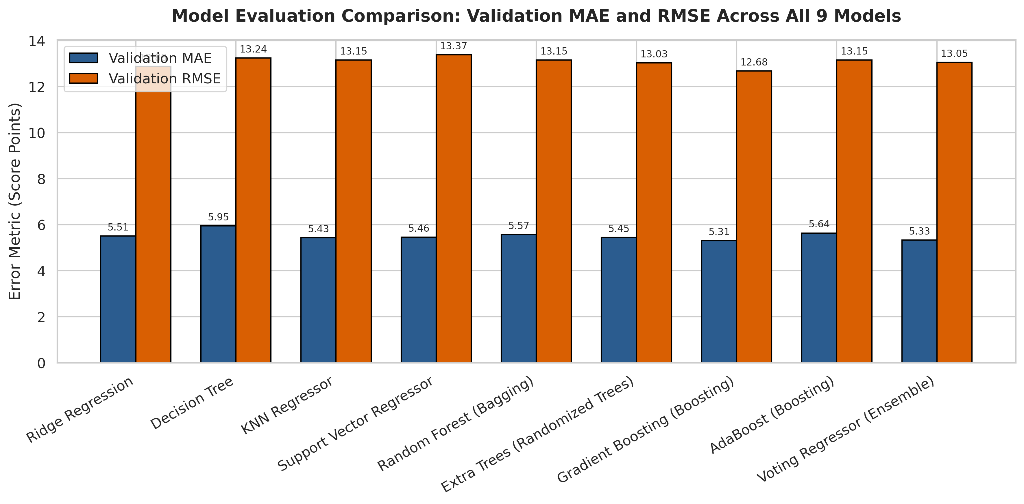
Figure 4: Validation MAE and RMSE of all nine models. Gradient Boosting has the lowest value on both.
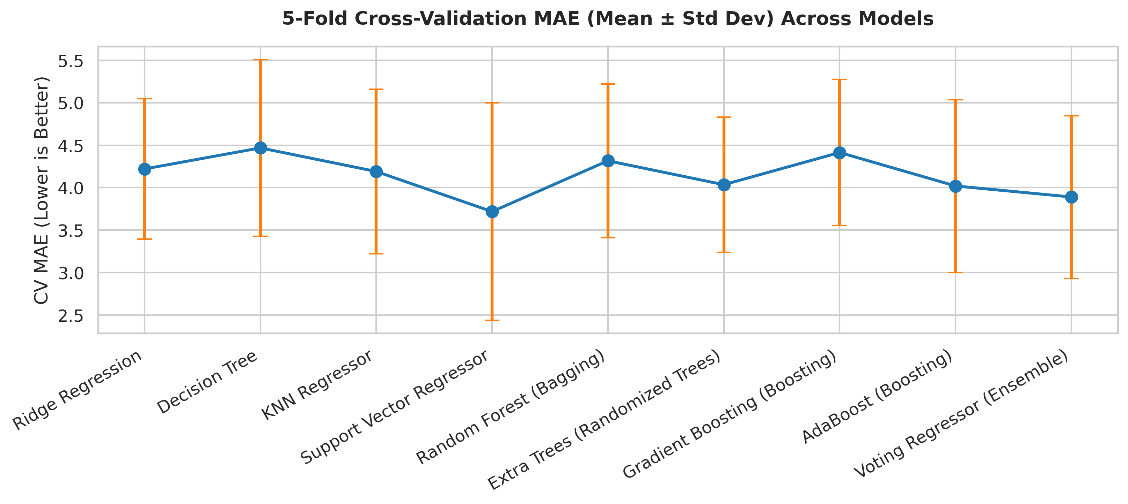
Figure 5: Cross-validation MAE with one standard deviation. The error bars overlap for most models.
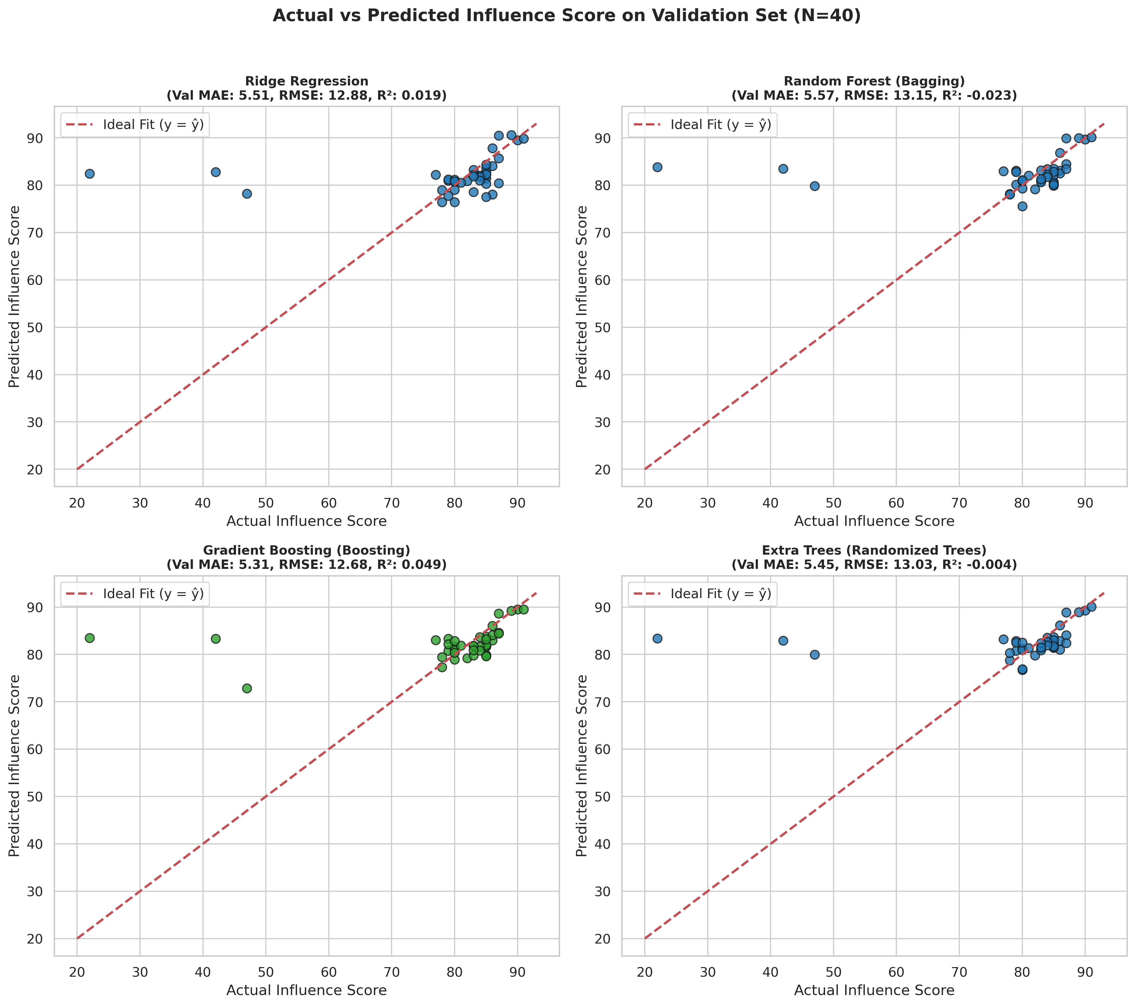
Figure 6: Actual and predicted scores on the validation set. Very low true scores are not predicted.
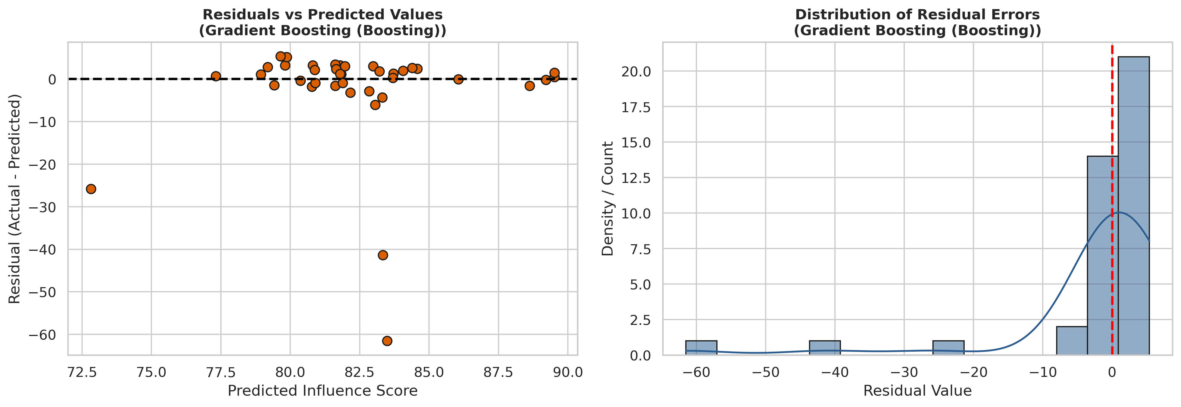
Figure 7: Residuals of Gradient Boosting. Three accounts are over-predicted by about 26, 41 and 61 points; the rest are within about 6 points.
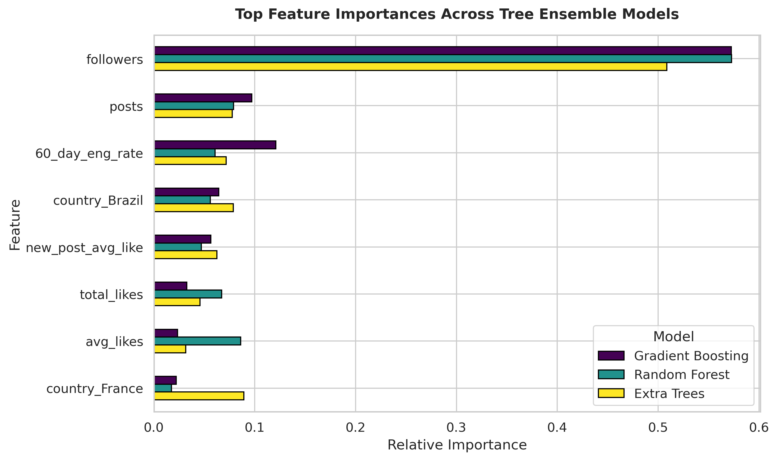
Figure 8: Feature importances of the three tree ensembles. Followers is the most important feature (about 0.51 to 0.57).
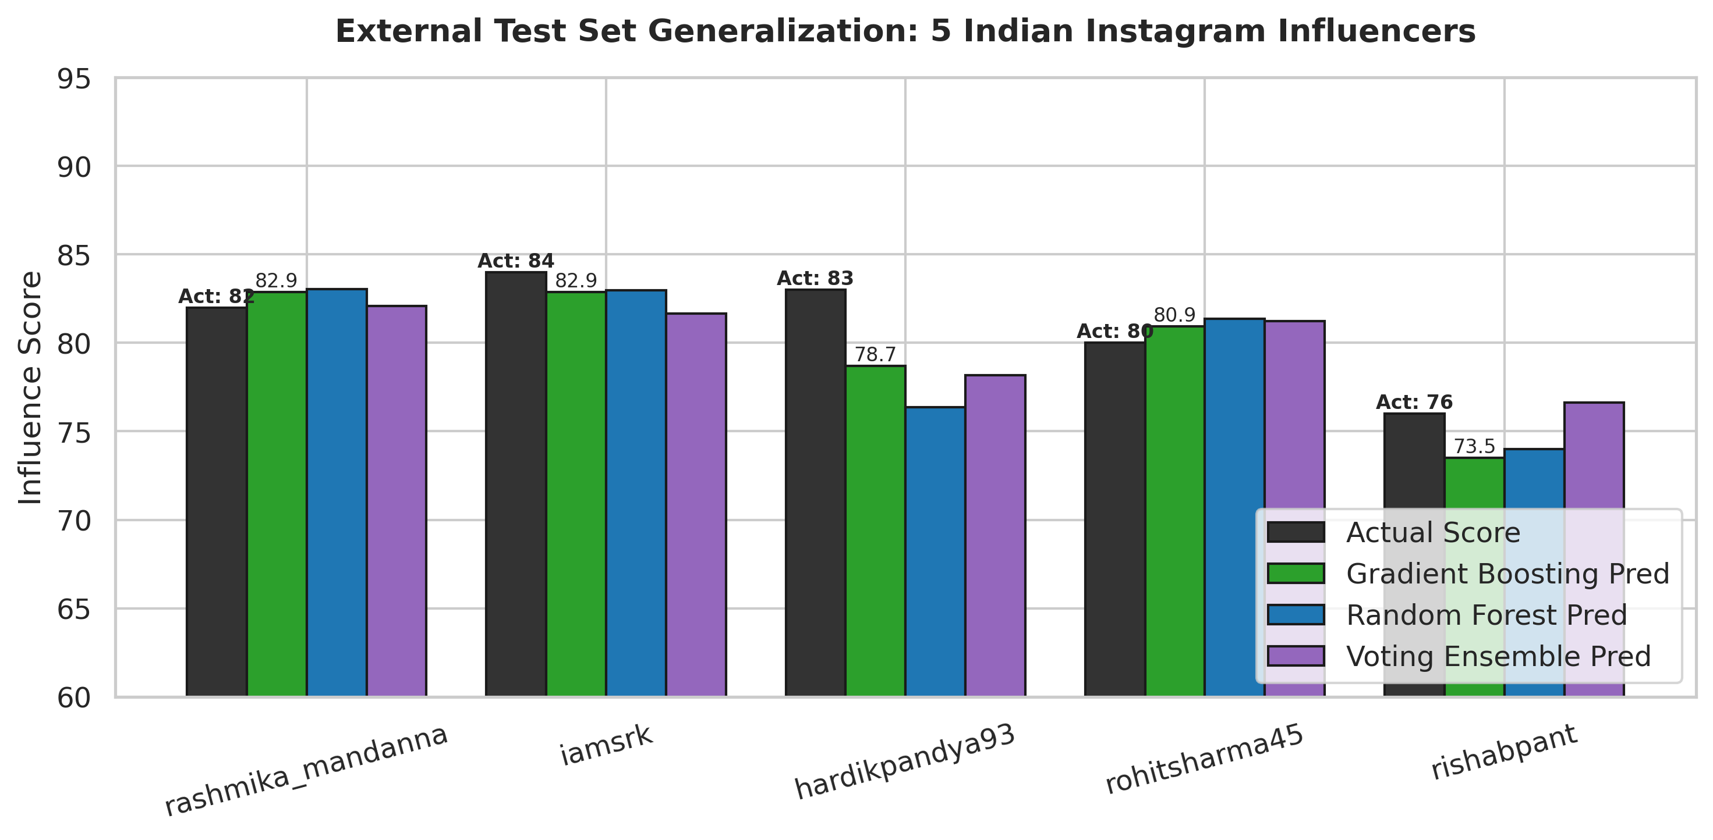
Figure 9: Predicted and actual scores for the five external influencers.

6. Model Comparison and Selection of the Best Model
To compare the models on several criteria at once, Table 7 ranks them (1 is best) on CV MAE, validation MAE, validation RMSE and external MAE. The mean rank gives equal weight to each criterion and is only a summary.
Table 7: Rank of each model on four criteria
No. | Model | CV MAE | Val MAE | Val RMSE | Ext MAE | Mean
1 | Voting Regressor | 2 | 2 | 4 | 2 | 2.50
2 | Gradient Boosting | 8 | 1 | 1 | 3 | 3.25
3 | Extra Trees | 4 | 4 | 3 | 4 | 3.75
4 | AdaBoost | 3 | 8 | 5 | 1 | 4.25
5 | Support Vector Regressor | 1 | 5 | 9 | 6 | 5.25
6 | Ridge Regression | 6 | 6 | 2 | 7 | 5.25
7 | KNN Regressor | 5 | 3 | 6 | 9 | 5.75
8 | Random Forest | 7 | 7 | 7 | 5 | 6.50
9 | Decision Tree | 9 | 9 | 8 | 8 | 8.50

6.1 Observations
- The Decision Tree is last on three of the four criteria and has a negative CV R², which indicates high variance. Combining many trees (bagging or boosting) reduced the validation and external error.
- The models are close to each other. Validation MAE ranges only from 5.31 to 5.95, which is less than the fold-to-fold standard deviation of CV MAE (about 0.8 to 1.3). With 40 validation accounts such differences may be due to chance.
- All models improve only a little on the baseline. Predicting the training mean gives a validation MAE of 6.27; Gradient Boosting gives 5.31, about 15% lower. On the external set the baseline MAE is 2.26 and Gradient Boosting gives 1.95.
- The best model depends on the criterion. SVR is best on CV MAE, Gradient Boosting on validation MAE and RMSE, AdaBoost on the external set, and the Voting Regressor has the best mean rank (2.50 against 3.25 for Gradient Boosting).

6.2 Selected model
We selected the Gradient Boosting Regressor (n_estimators = 80, learning_rate = 0.04, max_depth = 2, random_state = 42) and saved it as best_model_pipeline.joblib for the Streamlit application.
The main reason is performance on the 40 validation accounts, which were not used for fitting. On this set Gradient Boosting has the lowest MAE and RMSE and, together with Ridge, is one of only two models with a positive R² (+0.049). It also provides feature importances (followers about 57%), and it is a single compact model, which is simpler to save and deploy than the Voting Regressor, which combines four models.
The choice has limits. The CV MAE of Gradient Boosting (4.41) ranks 8th of 9, the Voting Regressor has the best mean rank, and AdaBoost is best on the external set. We therefore regard Gradient Boosting as a reasonable choice for deployment and not as a clear winner. More data and repeated cross-validation would be needed to separate the top models.

7. Responsible Use of AI Tools

7.1 Declaration of AI usage with prompts
We used an AI assistant (Claude) for explanations and small code snippets. We did not use it to choose the problem or dataset, to shortlist the models, to decide the final model, or to write the conclusions. The prompts we used are listed in Table 8.
Table 8: Prompts used and what we did with the answers
No. | Used for | Prompt | What we did with the answer
1 | Parsing text numbers | My CSV stores counts as strings like 3.3k, 475.8m, 29.0b and engagement as 1.39%. Write a Python function that converts them to floats and returns NaN for missing values. | Used as a starting point and tested on NaN, empty strings and the % sign. It ran without errors on all 205 rows. Kept as to_number().
2 | Understanding data leakage | Explain data leakage in scikit-learn. Why must the imputer and scaler be fitted only on training data, and how does a Pipeline help? | Used to understand the idea. We then placed every fitted step inside a Pipeline and ColumnTransformer fitted on the 160 training rows.
3 | ColumnTransformer syntax | How do I apply median imputation, log1p and StandardScaler to numeric columns, and a constant imputer plus OneHotEncoder with min_frequency to a categorical column, in one ColumnTransformer? | Used as a syntax reference only. The choice of columns and steps was ours (Section 3.2).
4 | Bagging and boosting | In simple words, what is the difference between bagging (Random Forest, Extra Trees) and boosting (Gradient Boosting, AdaBoost), and what does a Voting Regressor do? | Used for viva preparation. Section 6 was written by us after checking against our results.
5 | Metric interpretation | My validation R² is close to zero but MAE is about 5 on a score with median 84. Why can they disagree, and which metric should I trust when there are outliers? | This led us to plot the residuals and find three extreme low-score accounts (Figure 7). We report MAE and RMSE together.
6 | Error-bar chart | Matplotlib: how do I draw a bar chart of mean CV MAE for several models with standard deviation error bars? | Adapted for Figure 5.
7 | Streamlit layout | How do I load a joblib pipeline once in Streamlit with st.cache_resource, add a sidebar page selector, a CSV file_uploader and tabs for charts? | Used for the basic layout of app.py. The tier cut-offs, preset profiles and per-influencer graphs were designed by us.
8 | Instagram data | Which Python libraries can fetch the follower count of a public Instagram profile, and which metrics are not publicly available? | Learned the options and limits. The app uses stored values for accounts in the dataset and labelled estimates for others.

7.2 Critical evaluation of AI output
We did not accept AI-generated text or code without checking it against our own notebook output and plots. Table 9 lists the problems we found.
Table 9: Checks on AI-generated content
What the draft said | How we checked | Result
Some CV R² values in the draft report (e.g. Decision Tree −1.354, Voting +0.165) | Compared every table value with model_evaluation_metrics.csv | The values were wrong (actual −0.114 and +0.204). All tables were rebuilt from the CSV file.
The Voting Regressor was called stacking | Read the code: it averages the base model predictions and has no meta-learner | Relabelled as voting.
Country encoding gives 11 columns | Printed get_feature_names_out() of the fitted preprocessor | It gives 9 one-hot columns and 15 features in total.
Residuals described as symmetric and Gaussian | Looked at Figure 7 | Three large outliers make the distribution skewed. The description was corrected.
Notebook text said Gradient Boosting is “conclusively” the best | Compared all criteria and the baseline (Section 6) | The claim was too strong. The differences are small, so the choice is stated with its limits.
External MAE of 1.95 presented as proof of generalisation | Computed the same metric for the baseline | The baseline gives 2.26 and there are only five accounts, so it is only a sanity check.

7.3 Reflection on learning
- Building the Pipeline and ColumnTransformer showed us how easily information from the validation data can leak into training if scaling or imputing is done before the split. Dropping rank made the same point, since it is derived from followers.
- An MAE of about 5 looked acceptable until we compared it with the baseline (6.27) and saw that R² stayed close to zero. Comparing with a baseline is a habit we will keep.
- Three accounts with scores between 22 and 47 explain most of the RMSE. Looking at the residuals, and not only the summary numbers, helped us understand this.
- Running Random Forest, Extra Trees, Gradient Boosting and AdaBoost on the same data made the difference between bagging (reducing variance) and boosting (reducing bias) clear. It also showed why shallow trees suit only 160 training rows.
- Deployment raised new questions. Instagram does not publish average likes or engagement publicly, so the application has to show which inputs are exact and which are estimates.
- With more accounts and repeated cross-validation the model comparison would be more reliable. A loss function less sensitive to extreme scores is another possible improvement.

7.4 Problem analysis and design ownership
The decisions in Table 10 were made by the team. AI assistance (Section 7.1) was limited to the tasks listed in Table 8.
Table 10: Design decisions
Decision | What we decided | Reason
Problem framing | Regression on influence_score using public account metrics | The score is numeric and its size matters to sponsors
Leakage control | Dropped rank and channel_info; all fitted steps inside one Pipeline | rank is derived from followers; validation data must stay unseen
Transformations | log1p, StandardScaler, Unknown category for country | Skewed counts and 31% missing country
Model shortlist | Nine models: linear, tree, instance-based, kernel, bagging, boosting and voting | Covers a range of methods with five ensembles
Settings | Shallow trees and a small learning rate (Gradient Boosting: depth 2, 80 trees, 0.04) | Only 160 training rows, so deep models overfit
Evaluation | CV, validation and external sets; MAE as main metric; mean baseline | Three views of generalisation; MAE is less affected by outliers
Final model | Gradient Boosting, with its limits stated | Lowest validation MAE and RMSE; interpretable; compact
Application | Stored values for known accounts, no synthetic profiles, labelled estimates otherwise | Predictions for real influencers should use real data

All results in this report were produced by running our own notebook and can be traced to the submitted files. Both team members can explain each step of the pipeline, each metric and the reasoning behind the final model choice.

Appendix: Submitted Files
File | Purpose
ML_Mini_Project_Phase3_Instagram_Influencers.ipynb | Complete Python code: preprocessing, nine models, cross-validation, plots, model export
app.py, instagram_fetch.py | Streamlit application and the helper used to fetch live statistics
best_model_pipeline.joblib | Saved Gradient Boosting pipeline (preprocessing and model)
model_evaluation_metrics.csv, model_metadata.json | Metrics of all models; details of the selected model
top_insta_influencers_data.csv, indian_influencers_test.csv | Training dataset and external test set
plots/ | The six evaluation figures used in Section 5
requirements.txt | Python packages needed to run the code

To run: install the packages with pip install -r requirements.txt, run all cells of the notebook, and start the application with streamlit run app.py.

